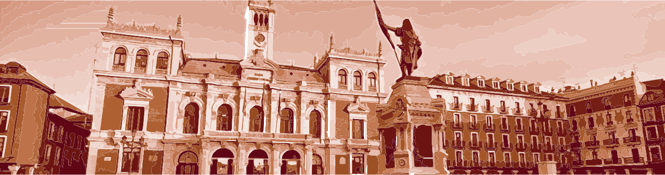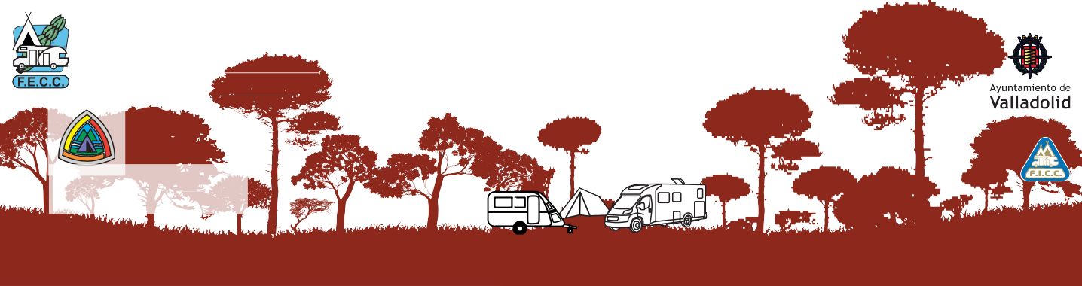

**FEDERACIÓN ESPAÑOLA**

DE CLUBES **CAMPISTAS**

**Organiza:**

**Camping Caravaning Club Duero de Valladolid**

62ª Concentra~~c~~i~~ón~~ Nacional de la F.E.C.C.

Coordenadas: 41°35’47”N / 4°45’25”W Valladolid, del 4 al 12 de abril de 2020 Lugar: Ctra. Rueda (antigua Hípica) CL-610, km. 4,5

# RELACION DE INSCRITOS

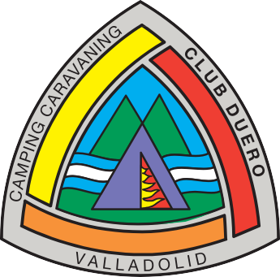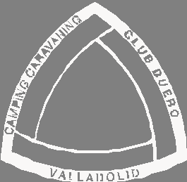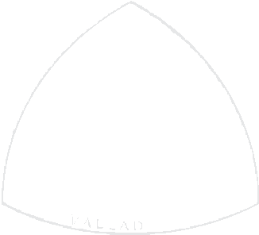

## **CLUB: _________________________________________________________________**

|  |  |  |  |  |  |  |  |
| --- | --- | --- | --- | --- | --- | --- | --- |
| **Nº** | **APELLIDOS** | **NOMBRE** | **AD.** | **JO.** | **NI.** | **INSTALACION** | **IMPORTE** |
|  |  |  |  |  |  |  |  |
|  |  |  |  |  |  |  |  |
|  |  |  |  |  |  |  |  |
|  |  |  |  |  |  |  |  |
|  |  |  |  |  |  |  |  |
|  |  |  |  |  |  |  |  |
|  |  |  |  |  |  |  |  |
|  |  |  |  |  |  |  |  |
|  |  |  |  |  |  |  |  |
|  |  |  |  |  |  |  |  |
|  |  |  |  |  |  |  |  |
|  |  |  |  |  |  |  |  |
|  |  |  |  |  |  |  |  |
|  |  |  |  |  |  |  |  |
|  |  |  |  |  |  |  |  |
|  |  |  |  |  |  |  |  |
|  |  |  |  |  |  |  |  |
|  |  |  |  |  |  |  |  |
|  |  |  |  |  |  |  |  |
|  |  |  |  |  |  |  |  |
|  |  |  |  |  |  |  |  |
|  |  |  |  |  |  |  |  |
|  |  |  |  |  |  |  |  |
|  |  |  |  |  |  |  |  |
|  |  |  |  |  |  |  |  |
|  | **TOTALES..............................** |  |  |  |  |  |  |

CAMPING CARAVANING CLUB DUERO

Teléfonos Emiliano 605833713 Maite 690247479

https:62concentracionnacionalfecc.home.blog

Mail: cccduero@gmail.com